**Assignment SCM With Git**

1. **Creating Local Git Repository:**

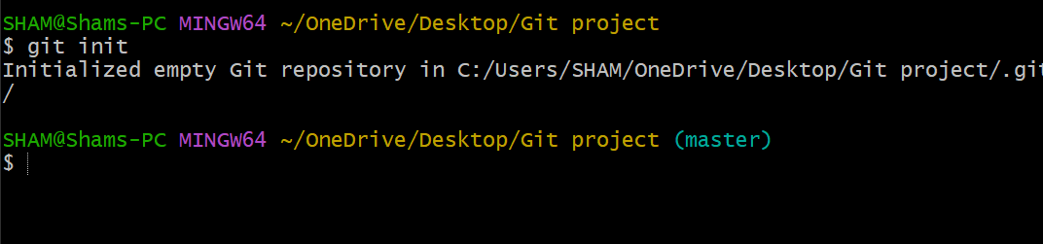

1. **Move the entire code base to it:**

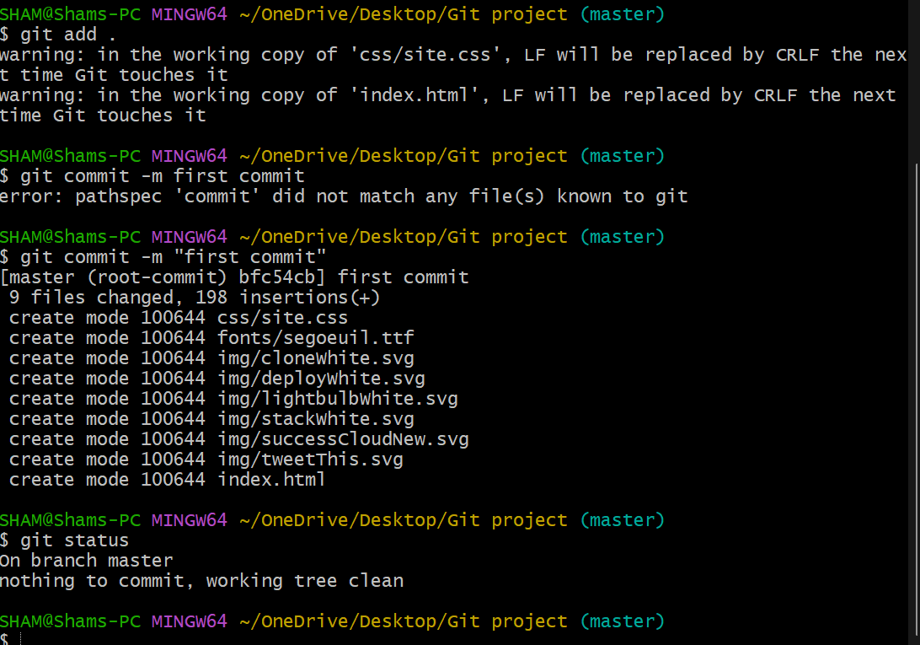

1. **Created a New Branch for a New Feature:**

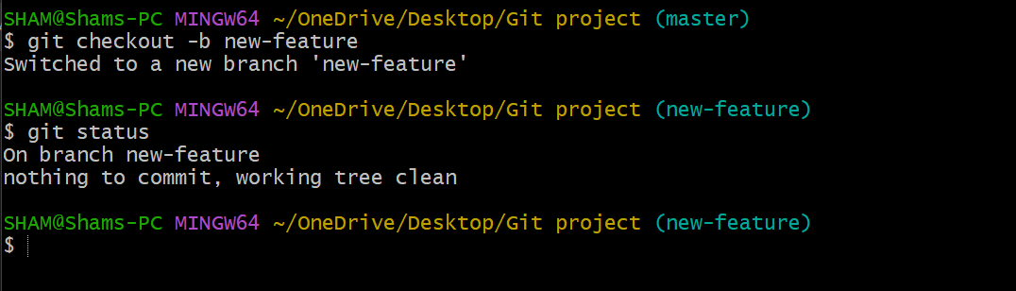

1. **Made the necessary code changes for the new feature:**

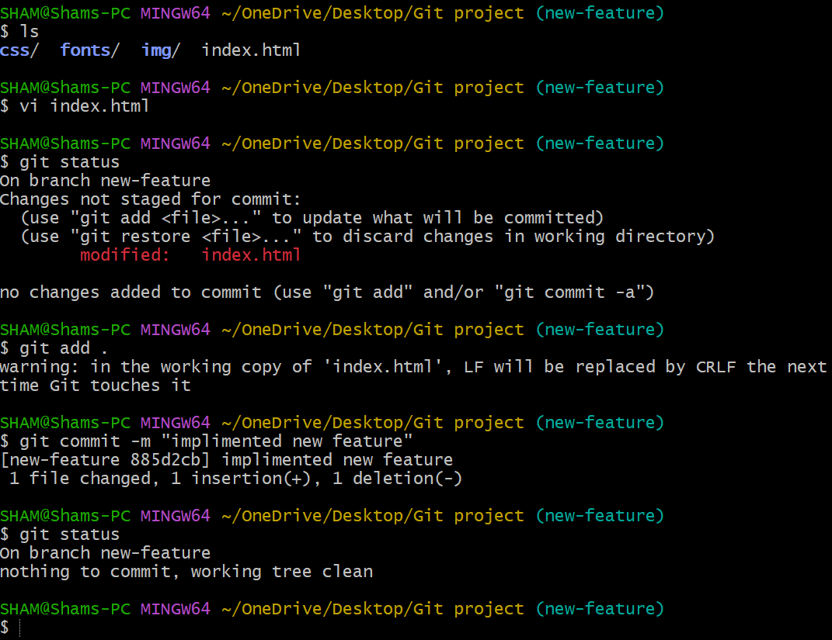

1. **Merging the feature Branch with the Master Branch:**

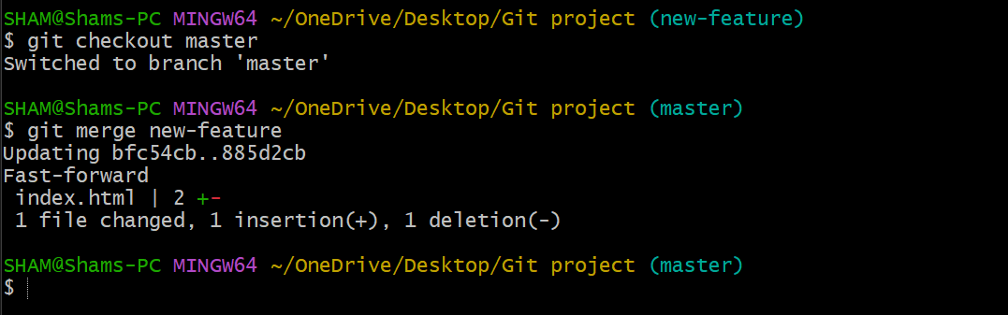

1. **Created a remote repository:**

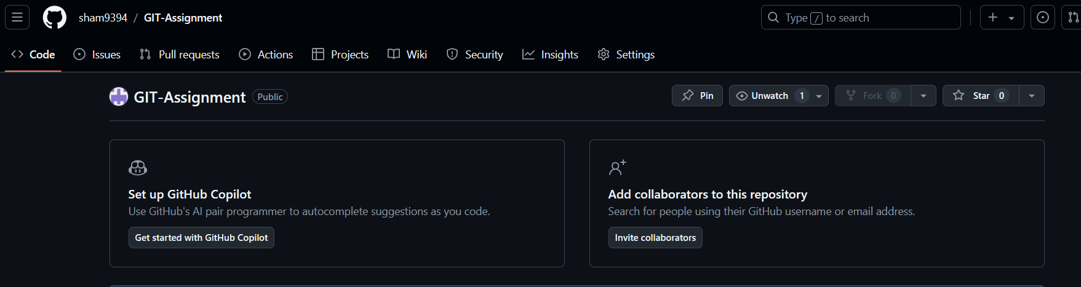

1. **Pushed all the code the local repository to remote repository:**

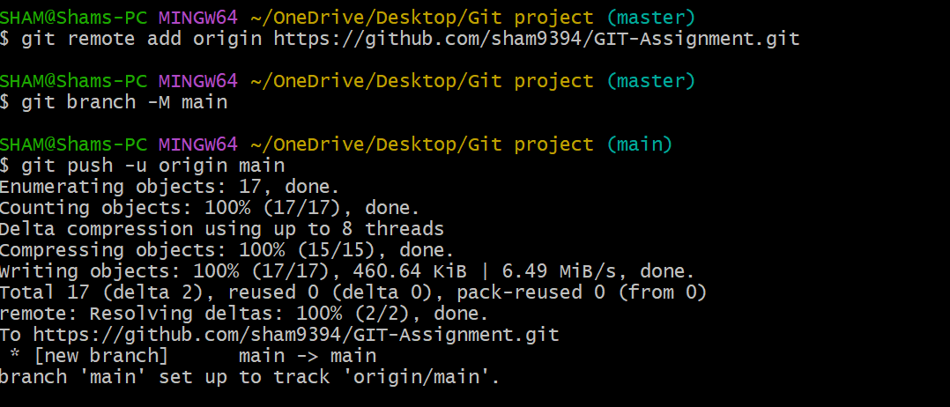

1. **Code available on remote repository:**

